Question # 1:
o calculate the clock cycle of a machine in the cluster, we need to follow the steps outlined below:
Given Data:
- Number of nodes = 10
- Maximum aggregate performance of the cluster = 640 GFLOPS (Giga Floating Point Operations per second)
- Number of cores per machine = 4 cores
- Clock speed of RAM = 3200 MHz (3.2 GHz)
- Each core can process 8 floating point operations per clock cycle
Step-by-Step Calculation:
1. Understand the relationship between GFLOPS and clock cycle:
- FLOPS (Floating Point Operations Per Second) is a measure of computational performance, representing the number of floating-point calculations a system can perform in one second.
- For a single machine, the performance in FLOPS depends on the number of cores, the number of floating-point operations per core per clock cycle, and the clock speed of the cores (in GHz).
2. Determine the performance per machine:
The aggregate performance of the cluster is 640 GFLOPS. Since there are 10 nodes, the performance of each machine is:
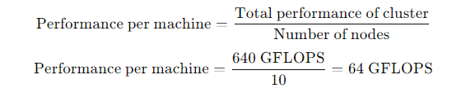
Thus, each machine can perform 64 GFLOPS.
3. Calculate the total FLOPS a single machine can achieve:
For each machine, the total number of FLOPS can be calculated as:
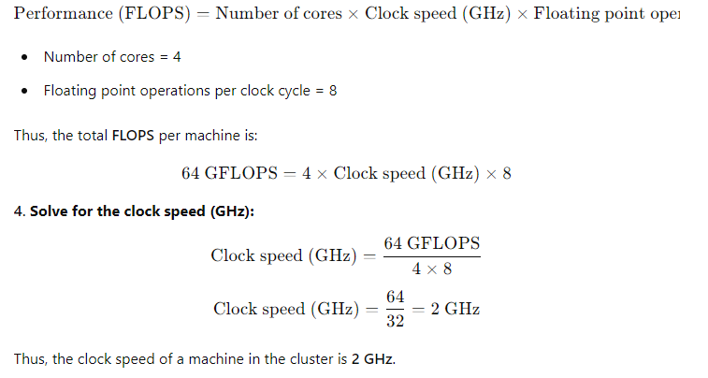
Final Answer:
The clock speed of a machine in the cluster is 2 GHz.
Question # 2:
To calculate the maximum aggregate performance of the cluster in GFLOPS (Giga Floating Point Operations per second), we need to evaluate the performance of both the newer half of the cluster and the older half of the cluster, then sum their performances.
Step-by-Step Calculation:
Given Data:
- Cluster composition: 50 nodes total
  - Half of the cluster has newer machines.
  - Half of the cluster has older machines.
- Newer machines (25 machines):
  - Number of cores per machine: 96 cores
  - Clock rate of each core: 2.4 GHz
  - Floating point operations per core per clock cycle: 16 FLOPs
  - RAM: 3600 MHz DDR4
- Older machines (25 machines):
  - Number of cores per machine: 12 cores
  - Clock rate of each core: 2.0 GHz
  - Floating point operations per core per clock cycle: 8 FLOPs
  - RAM: 3200 MHz DDR4
1. Calculate the performance of the newer machines:
The performance of a single newer machine can be calculated as:
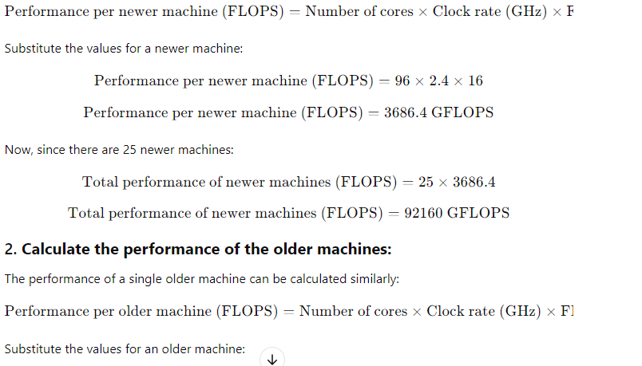
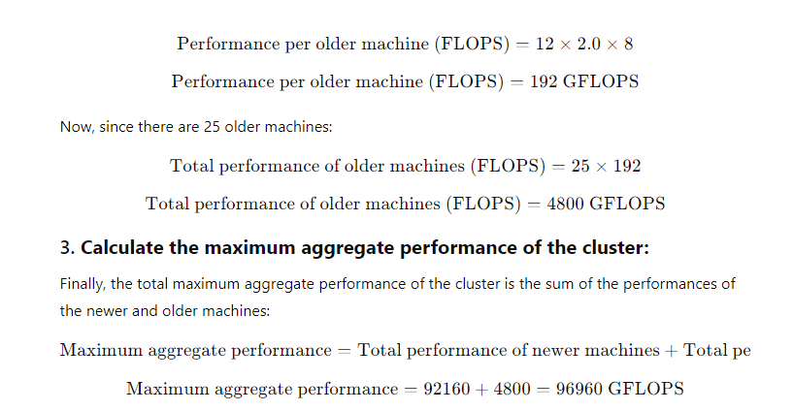
Final Answer:
The maximum aggregate performance of the cluster is 96,960 GFLOPS.

Question # 3:
To solve this problem, we need to break down the statements and analyze the impact of transmission delay and message size on the ability to detect whether a node is alive or dead in a cluster network.
Let's define the components and relevant calculations to help understand the answer:
1. Transmission Delay Calculation
- Message size: 2 MB = 2,000,000 bytes
- Link speed: 1 Gbps = 1,000,000,000 bits per second
- Conversion: 1 byte = 8 bits, so the message size in bits = 2,000,000 × 8 = 16,000,000 bits
- Transmission delay is calculated as:
Transmission delay is calculated as:
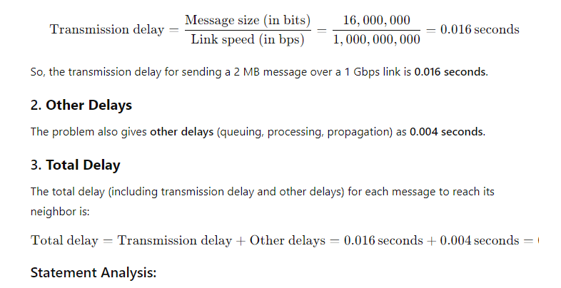
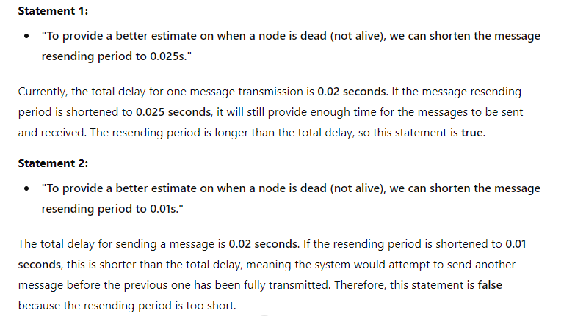
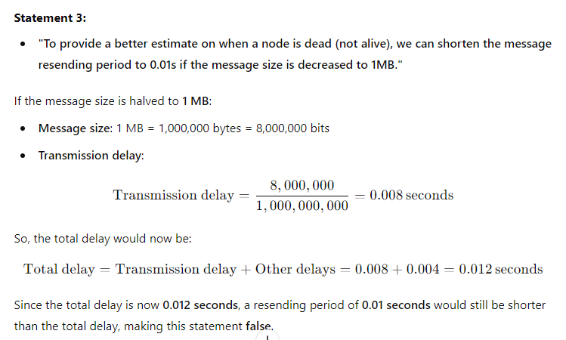
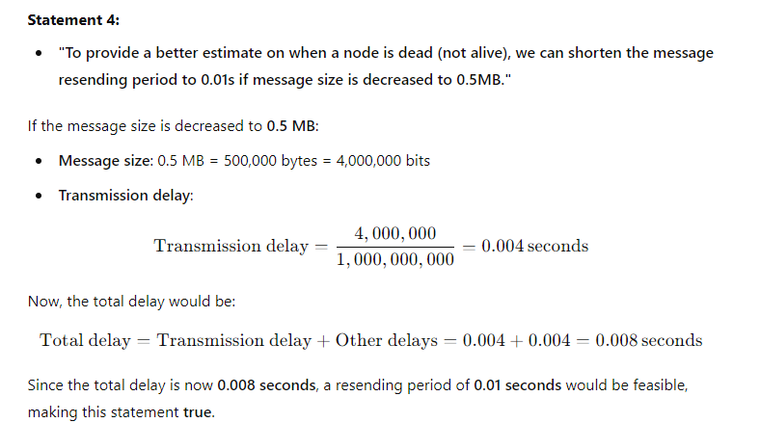
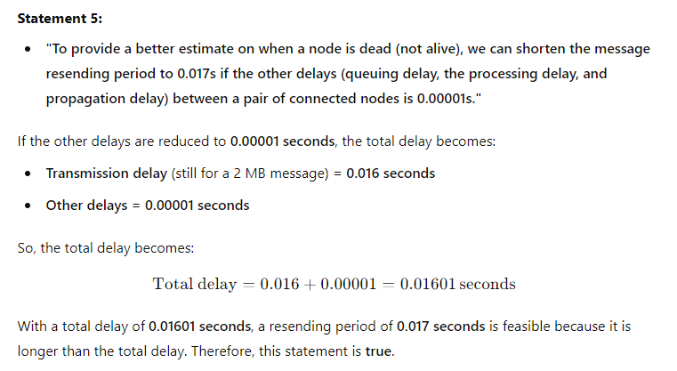
Final Answers:
- True: Statement 1, Statement 4, Statement 5
- False: Statement 2, Statement 3

Question # 4:
To determine which of the statements are true, we first need to calculate the transmission delay and assess fault tolerance for different topologies. We are looking for fault tolerance, meaning that even if one link fails, the message must still be received by any node from any other node in under 0.03 seconds.
Step-by-step breakdown:
Transmission delay calculation:
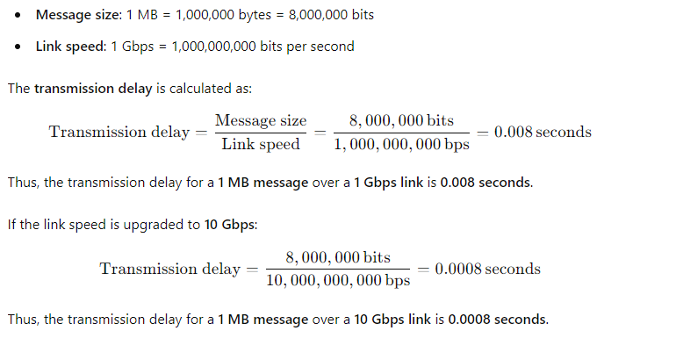
Fault tolerance assessment:
The total time to transmit a message must be under 0.03 seconds for the network to be considered fault-tolerant. We need to consider the impact of a single link failure and the topology of the network.
Analysis of Statements:
- "If the machines are connected in a line topology, the network is not fault-tolerant."
  - In a line topology, a failure of a single link splits the network into two disconnected parts. Therefore, messages cannot be sent from one node to another across the entire network when a link fails.
  - Hence, this statement is true: a line topology is not fault-tolerant because the failure of one link disconnects nodes.
- "If the machines are connected in a line topology, the network is fault-tolerant if the links are upgraded to 10Gbps link."
  - Even if the links are upgraded to 10 Gbps, a single link failure in a line topology would still disconnect parts of the network. Thus, the network remains non-fault-tolerant, regardless of link speed.
  - Hence, this statement is false.
- "If the machines are connected in a binary tree topology, the network is not fault-tolerant."
  - In a binary tree topology, a single link failure can isolate nodes in subtrees, preventing communication between parts of the network. This is because the binary tree has no redundant paths to account for a link failure.
  - Hence, this statement is true: a binary tree topology is not fault-tolerant.
- "If the machines are connected in a binary tree topology, the network is fault-tolerant if the links are upgraded to 10Gbps link."
  - The issue with fault tolerance in a binary tree topology is the lack of redundant paths, not the speed of the links. Upgrading the link speed to 10 Gbps does not fix the fault tolerance problem, as a single link failure still isolates parts of the network.
  - Hence, this statement is false.
- "If the machines are connected in a ring topology, the network is not fault-tolerant."
  - In a ring topology, if one link fails, the message can still be routed in the opposite direction along the ring. This makes the ring topology fault-tolerant by design, as there is an alternative path for communication.
  - Hence, this statement is false.
- "If the machines are connected in a ring topology, the network is fault-tolerant if the links are upgraded to 10Gbps link."
  - A ring topology is already fault-tolerant by design. The link upgrade to 10 Gbps only improves transmission speed but does not affect the inherent fault tolerance. Thus, the network would remain fault-tolerant regardless of the link upgrade.
  - Hence, this statement is true: a ring topology is fault-tolerant, and the upgrade to 10 Gbps would enhance performance but not fault tolerance.
Summary of Answers:
- True: Statement 1, Statement 6
- False: Statement 2, Statement 3, Statement 4, Statement 5

